RIWAYAT SABMIT JURNAL

The Role of Culture, Beliefs and Ceremonies in the Development of Society

Kasma F. Amin¹, Imam Muhsin², Lilik Prasetyarini³, Jumintono⁴,

Azam Kholikov⁵, Layth Hussein⁶,⁷,⁸

Nama Jurnal: Evolutionary Studies in Imaginative Culture

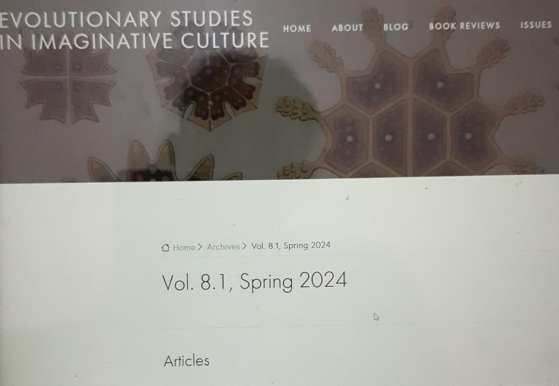

No | Kegiatan | Waktu | Ket.
A | Proses artikel | Januari-Oktober 2024
B | Submit Ringkasan | 10 November 2023 | By ojs
C | Artikel profil (artikel review procedur)  Registrasi  Submitted Manuscrip by system  Respon manuskrip  4. Perbaikan perreviwer  Ket Publish  Posted | 7 Desember 2023  7 Desember 2024  12 Desember 2024  15 Desember 2024  2 April 2024  16 April 2024 | Link Jurnal dan E-mail
C. | Online Publishing | Vol.8/No.1/Spring April 16 April 2024 | By link

Registrasi:

Star registrasi



Upload submission


- Upload file artikel

- Upload metadata dan Abstrak


List of Contributors:
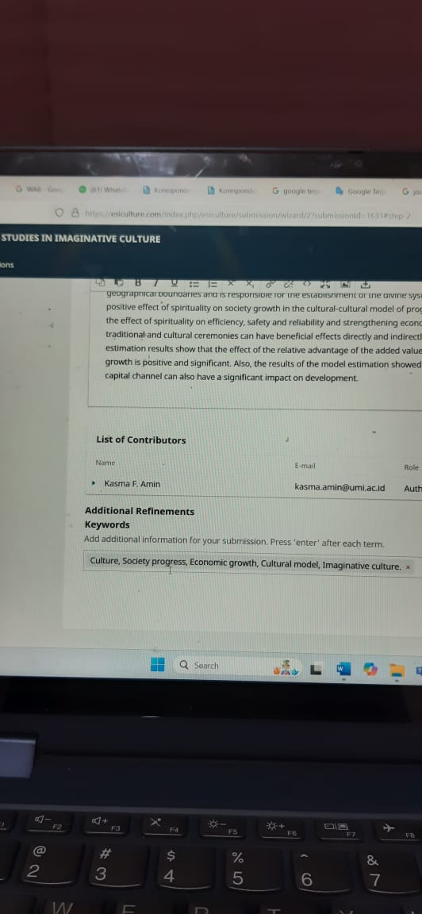
- Konfirmasi:


Referee's Report (Reviewer-Evolutionary Studies in Imaginative Culture)

Paper No. | 580
Title | The Role of Culture, Beliefs and Ceremonies in the Development of Society
Author (s) | Kasma F. Amin, Imam Muhsin, Lilik Prasetyarini, Jumintono, 6Kholikov, Layth Hussein  DOI:10.70082/esic/8.1.029

I. CONTENTS
1. Type of paper :
Theoretical research
Experimental research
Review of existing technique
Other
2. Originality :
Original work
Minor extension of known technique
Nothing specially new
Other
3. Significance :
High value of current interest
Marginal value of current interest
No significant value
Other
4. Completeness :
Complete
Omission of important part (specified in IV)
Contains unnecessary portion (specified in IV)
Other
5. Comprehensi6ility :
Well written, Easily understood
Several reading are needed to understand
Virtually unreadable (need rewriting by a native English speaker)
6. Details (If No, please specify in IV) :
yes / no
/ Adequacy of title?
/ Adequacy of summary & conclusions??
/ Adequacy of length?
/ Adequacy of references?
II. OVERALL RATING
Poor
Marginal
Average
Good
Excellent
III. RECOMMENDATION
Accept as is
Accept if minor revisions are made (REREVIEW unnecessary)
Accept only if required revisions are made (REREVIEW necessary)
Reject (reasons specified in VI)

IV. COMMENTS
Manuscript Number: ESIC-580
Full Title: The Role of Culture, Beliefs and Ceremonies in the Development of Society

A) how do you measure the effects of ceremonies in society and culture, by national ones in studied area?
- The studied area culture, religious and culture should be explained.
- provide the citation for the second paragraph in introduction

- The proposed methodology and collection of data should be explained, is it based on questioners?
- The references type should be in APA.
- have you considered the economic growth in your results, mention it in abstract and
results.
- the literature review is to wordy, shorten them and focus on main results.

Response Reviwer dan Hasil Revisi:

Title | The Role of Culture, Beliefs and Ceremonies in the Development of Society
Author (s) | Kasma F. Amin, Imam Muhsin, Lilik Prasetyarini, Jumintono, 6Kholikov, Layth Hussein

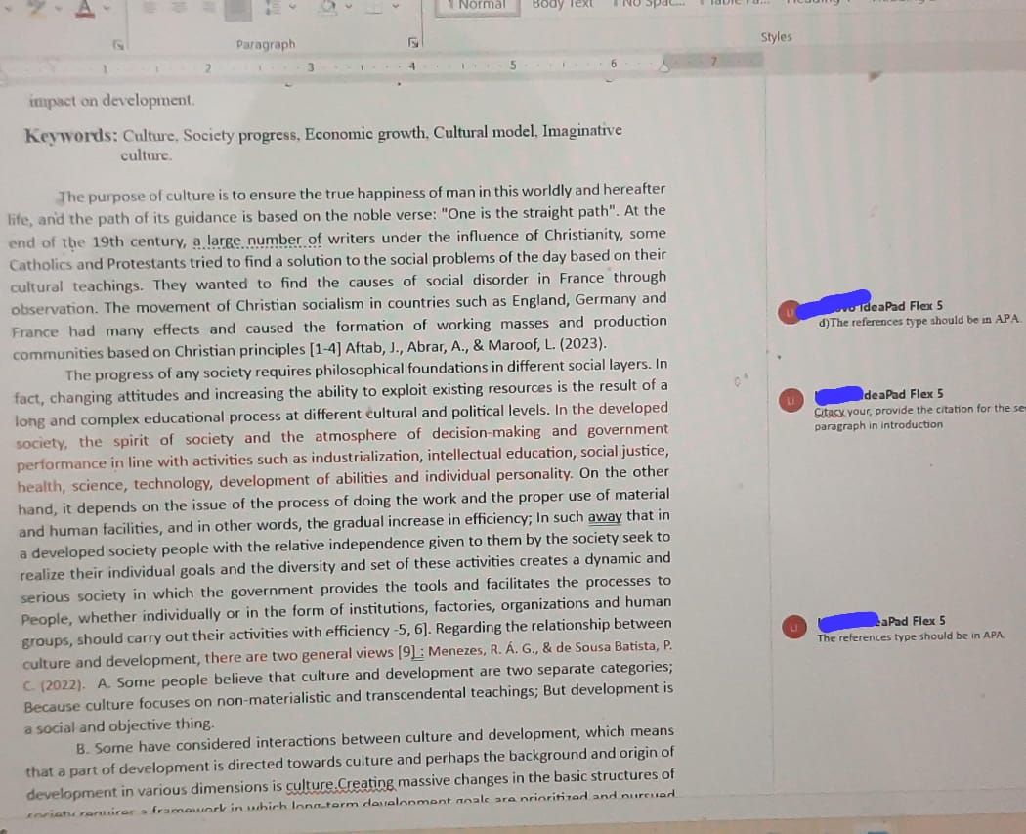
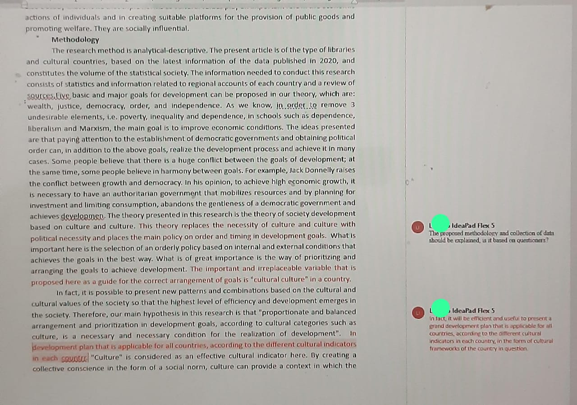

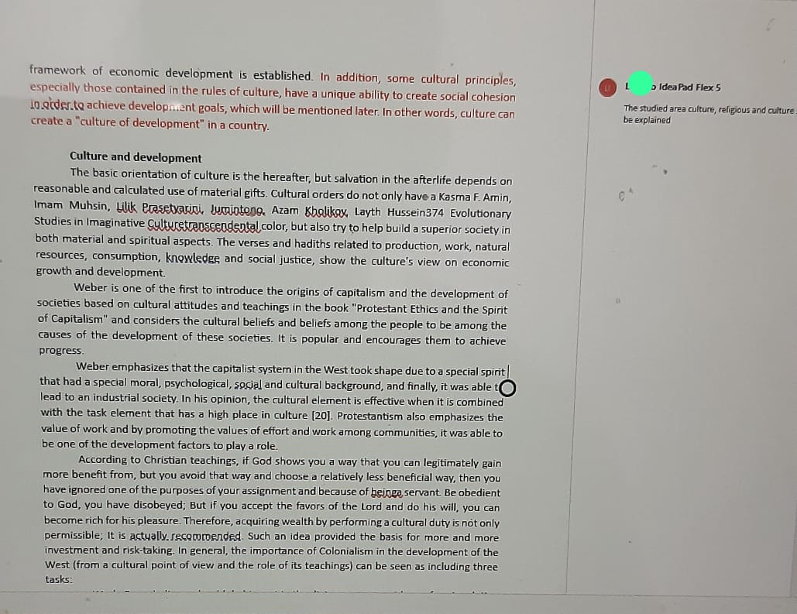

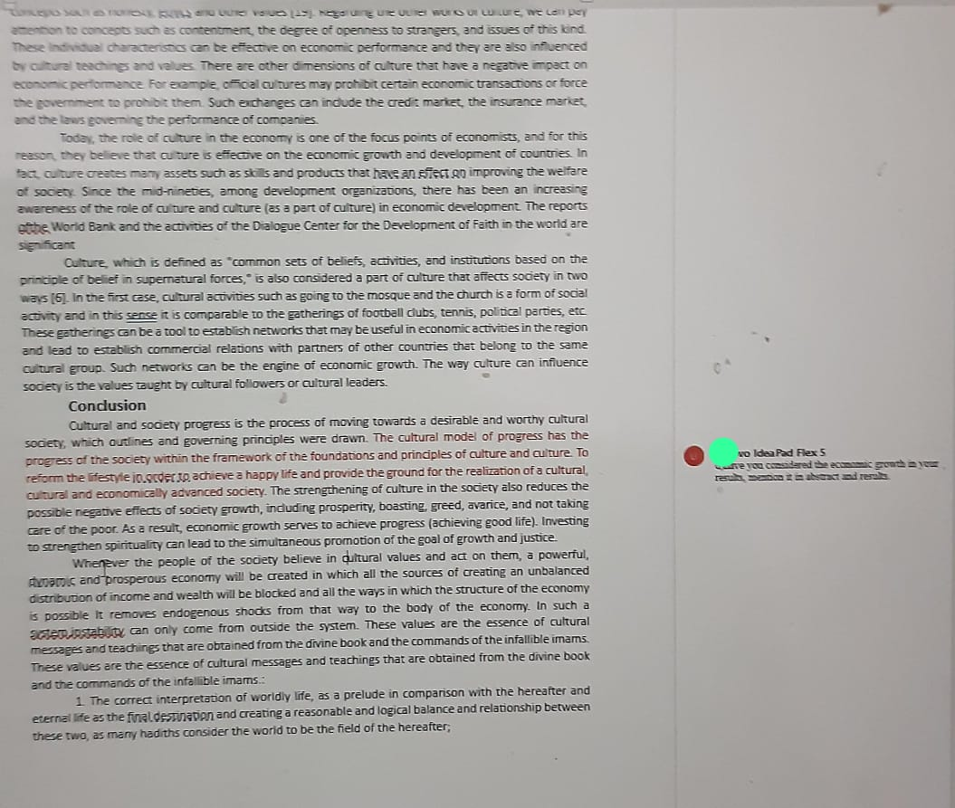

Hasil Revisi Author : 29 Desember 2023

The Role of Culture, Beliefs and
Ceremonies in the Development of Society

Kasma F. Amin¹, Imam Muhsin², Lilik Prasetyarini³, Jumintono⁴,
Azam Kholikov⁵, Layth Hussein⁶,⁷,⁸

¹Universitas Muslim Indonesia, kasma.amin@umi.ac.id
²UIN Sunan Kalijaga Yogyakarta, Indonesia, imam.muhsin@uin-suka.ac.id
³UIN Raden Mas Said, Surakarta, Indonesia, lilikprasetyarini2019@gmail.com
⁴Universitas Sarjanawiyata Tamansiswa, Yogyakarta, Indonesia; masmintosragen@gmail.com Doctor of Pedagogy, Professor, Head of the Department of Mother Language and Teaching Methodology in Primary Education, Tashkent State Pedagogical University, Tashkent, Uzbekistan, ayntraxt@gmail.com
⁶Department of computers Techniques engineering, College of technical engineering, The Islamic University, Najaf, Iraq
⁷Department of computers Techniques engineering, College of technical engineering, The Islamic University of Al Diwaniyah, Al Diwaniyah, Iraq.
⁸Department of computers Techniques engineering, College of technical engineering, The Islamic University of Babylon, Babylon, Iraq; laith.h.alzubaidi@iunajaf.edu.iq
-------------------------------------------------------------------------------------------------------------------
Abstract
Cultural teachings have a lot of emphasis on various fields of human development in different dimensions. In order to achieve all-round development, the correct use of cultural teachings seems necessary and necessary; because the goal of the divine school is the evolution and excellence of man, so that a person can achieve external growth at the global level in the shadow of intellectual and spiritual growth that originates from within people. The main purpose of this article is to provide definitions of development and culture, to examine the fields of connection between these two debates and the role of cultural teachings on the principle of development, and by stating this point of view that cultures try to manage people's lives and on the other hand, in the new world. Various phenomena have emerged, each of which affects the way of life of humans in its own way; Therefore, in this situation for a cultural society, the most important issue is to express the relationship between culture and the new world. The cultural school emphasizes on global development, which should be in the hands of everyone and for everyone, and the only way to achieve this development is a universal revolution, which is realized in the shadow of need, on a global level, and leads to a comprehensive transformation and growth and spiritual and intellectual evolution that the root of material growth is sustainable, with complete interaction and balance without harming others - not only humans, but also the nature around us. The teachings of divine cultures have in many cases emphasized on the dimensions of universal and its development and claim that the last savior is not limited to geographical boundaries and is responsible for the establishment of the divine system on a global level. The mechanism of the positive effect of spirituality on society growth in the cultural-cultural model of progress are explained from at least three paths of the effect of spirituality on efficiency, safety and reliability and strengthening economic justice. Cultural issues, performing traditional and cultural ceremonies can have beneficial effects directly and indirectly on society and economic growth. Also, the estimation results show that the effect of the relative advantage of the added value of cultural variables on society and economic growth is positive and significant. Also, the results of the model estimation showed that cultural and culture though the human capital channel can also have a significant impact on development.

Keywords: Culture, Society progress, Economic growth, Cultural model, Imaginative
culture.

The purpose of culture is to ensure the true happiness of man in this worldly and hereafter life, and the path of its guidance is based on the noble verse: "One is the straight path". At the end of the 19th century, a large number of writers under the influence of Christianity, some Catholics and Protestants tried to find a solution to the social problems of the day based on their cultural teachings. They wanted to find the causes of social disorder in France through observation. The movement of Christian socialism in countries such as England, Germany and France had many effects and caused the formation of working masses and production communities based on Christian principles [1-4]
The progress of any society requires philosophical foundations in different social layers. In fact, changing attitudes and increasing the ability to exploit existing resources is the result of a long and complex educational process at different cultural and political levels. In the developed society, the spirit of society and the atmosphere of decision-making and government performance in line with activities such as industrialization, intellectual education, social justice, health, science, technology, development of abilities and individual personality, etc [5, 6]. On the other hand, it depends on the issue of the process of doing the work and the proper use of material and human facilities, and in other words, the gradual increase in efficiency; In such away that in a developed society people with the relative independence given to them by the society seek to realize their individual goals and the diversity and set of these activities creates a dynamic and serious society in which the government provides the tools and facilitates the processes to People, whether individually or in the form of institutions, factories, organizations and human groups, should carry out their activities with efficiency -7, 8]. Regarding the relationship between culture and development, there are two general views [9]: A. Some people believe that culture and development are two separate categories; Because culture focuses on non-materialistic and transcendental teachings; But development is a social and objective thing.
B. Some have considered interactions between culture and development, which means that a part of development is directed towards culture and perhaps the background and origin of development in various dimensions is culture.Creating massive changes in the basic structures of society requires a framework in which long-term development goals are prioritized and pursued in parallel. Reaching such a position requires understanding the national culture on the one hand and making fundamental changes in it through the identification and flourishing of talents in the values that govern the society such as cultural values in order to achieve economic development on the other hand. In general, today growth and development will not happen without cultural contexts, and any development relies on special cultural aspects. In this research, the role of the added value of the cultural-cultural sector on economic growth will be investigated, because we believe that the cultural-cultural indicators, which include goods, cultural ceremonies and cultural expenses, in turn lead to the formation of cultural capital and play an important role in the growth and have economic development.
Literature reviewThe concept of culture and its implications in the society development of individuals and societies have always been considered by its researchers. The claim that "culture and well-being" are related by different researchers which has been confirmed in [1,10]. This shows that culture includes ideas of change and transformation that, over several decades, concepts such as "growth", "equality", "coherence", "basic needs", He has nurtured "justice" and "poverty", "security", "health", "effort and hard work", "satisfaction" and others in his womb.
Social theorists from Karl Marx to Daniel Bell have argued that economic development is accompanied by comprehensive cultural change. Other theorists from Max Weber to Samuel Huntington claim that cultural values (have a permanent and independent influenceon the society and the relationship between culture and economic growth during the last fifty years cannot be considered coincidental, corresponding or relatively independent changes) [11]. Max Weber is right. The only thing we can learn from the history of economic development is that culture is the root of all differences. Max Weber believes that determining and following the moral principles of everyday life helps economic success. Therefore, special attention should be paid to culture as a determining factor in economic growth [12].
In [13] has conducted a study entitled "Economic Developments and Buddhism in Asia" in Asian countries. By stating the views for and against the impact of Buddhism on economic development, and the separation of the cultural beliefs of Buddhism, Taoism and Hinduism, he investigated the structure of the situation. Economic indicators such as human development, gross domestic product per capita, government expenses, income distribution, savings and investment ratio, balance of payments and education level and Sudra have been studied, then with a comparative comparison, he has discussed the economic developments with the influence of Buddhism.
In [14] investigated the cultural values and economic growth and tried to measure the impact of some specified cultural factors affecting selected Asian countries. This model both includes economic and cultural variables, so it is superior to other models that only consider economic growth. We enter the data of cultural factors between 1999 and 2007 into endogenous economic growth models. The results of the OLS test to test the influence of cultural and economic factors on growth It is economic in such a way that cultural views of trust, respect and self-determination have a positive effect on economic growth, but obedience has a negative effect on the economic growth of the countries under study.
In [15] studied the effect of culture on humanitarian aid, which shows that these mechanisms (such as endowment) are widely used to strengthen human and social development, especially in providing health, educational and educational services for the community. The results of the study "culture, social networks and satisfaction with life" is a study by [16] which indicates the fact that religiosity, when it enters social networks, creates a noticeable influence on the quality of life and satisfaction of cultural people. As a result, the mental well-being of people who have higher intragroup actions is higher than those who have less social ties. In [17] investigated the culture and work, which showed that there is a positive relationship between culture and work, but organizational estimates do not show any effect of the effect of Protestantism on people's hourly wages. In [18] culture, society management and public goods is also a study that shows that triple norms as cultural values play an important role in the economic actions of individuals and in creating suitable platforms for the provision of public goods and promoting welfare. They are socially influential.
Methodology
The research method is analytical-descriptive. The present article is of the type of libraries and cultural countries, based on the latest information of the data published in 2020, and constitutes the volume of the statistical society. The information needed to conduct this research consists of statistics and information related to regional accounts of each country and a review of sources.Five basic and major goals for development can be proposed in our theory, which are: wealth, justice, democracy, order, and independence. As we know, in order to remove 3 undesirable elements, i.e. poverty, inequality and dependence, in schools such as dependence, liberalism and Marxism, the main goal is to improve economic conditions. The ideas presented are that paying attention to the establishment of democratic governments and obtaining political order can, in addition to the above goals, realize the development process and achieve it in many cases. Some people believe that there is a huge conflict between the goals of development; at the same time, some people believe in harmony between goals. For example, Jack Donnelly raises the conflict between growth and democracy. In his opinion, to achieve high economic growth, it is necessary to have an authoritarian government that mobilizes resources and by planning for investment and limiting consumption, abandons the gentleness of a democratic government and achieves development [19]. The theory presented in this research is the theory of society development based on culture and culture. This theory replaces the necessity of culture and culture with political necessity and places the main policy on order and timing in development goals. What is important here is the selection of an orderly policy based on internal and external conditions that achieves the goals in the best way. What is of great importance is the way of prioritizing and arranging the goals to achieve development. The important and irreplaceable variable that is proposed here as a guide for the correct arrangement of goals is "cultural culture" in a country. And at the same time, the compromise between goals gives different effects. The five development goals can be a different meaningful model for different Christian, Jewish, Islamic or Hindu cultures and cultures.
In fact, it is possible to present new patterns and combinations based on the cultural and cultural values of the society so that the highest level of efficiency and development emerges in the society. Therefore, our main hypothesis in this research is that "proportionate and balanced arrangement and prioritization in development goals, according to cultural categories such as culture, is a necessary and necessary condition for the realization of development". In fact, it will be efficient and useful to present a grand development plan that is applicable for all countries, according to the different cultural indicators in each country, in the form of cultural frameworks of the country in question. "Culture" is considered as an effective cultural indicator here. By creating a collective conscience in the form of a social norm, culture can provide a context in which the framework of economic development is established. In addition, some cultural principles, especially those contained in the rules of culture, have a unique ability to create social cohesion in order to achieve development goals, which will be mentioned later. In other words, culture can create a "culture of development" in a country.

Culture and development
The basic orientation of culture is the hereafter, but salvation in the afterlife depends on reasonable and calculated use of material gifts. Cultural orders do not only have a Kasma F. Amin, Imam Muhsin, Lilik Prasetyarini, Jumintono, Azam Kholikov, Layth Hussein374Evolutionary Studies in Imaginative Culturetranscendental color, but also try to help build a superior society in both material and spiritual aspects. The verses and hadiths related to production, work, natural resources, consumption, knowledge and social justice, show the culture's view on economic growth and development.
Weber is one of the first to introduce the origins of capitalism and the development of societies based on cultural attitudes and teachings in the book "Protestant Ethics and the Spirit of Capitalism" and considers the cultural beliefs and beliefs among the people to be among the causes of the development of these societies. It is popular and encourages them to achieve progress.
Weber emphasizes that the capitalist system in the West took shape due to a special spirit that had a special moral, psychological, social and cultural background, and finally, it was able to lead to an industrial society. In his opinion, the cultural element is effective when it is combined with the task element that has a high place in culture [20]. Protestantism also emphasizes the value of work and by promoting the values of effort and work among communities, it was able to be one of the development factors to play a role.
According to Christian teachings, if God shows you a way that you can legitimately gain more benefit from, but you avoid that way and choose a relatively less beneficial way, then you have ignored one of the purposes of your assignment and because of beinga servant. Be obedient to God, you have disobeyed; But if you accept the favors of the Lord and do his will, you can become rich for his pleasure. Therefore, acquiring wealth by performing a cultural duty is not only permissible; It is actually recommended. Such an idea provided the basis for more and more investment and risk-taking. In general, the importance of Colonialism in the development of the West (from a cultural point of view and the role of its teachings) can be seen as including three tasks:
a. Work: Every believer should do his part in the divine government by performing duties in the direction of productive goals, because work in this ritual is considered as participation in the manifestation of God's glory and majesty.b. Tolerating hard conditions: a person must live hard and use wealth in productive and welfare ways. C. Education: Every person should have knowledge, especially experimental sciences to understand the works of God. Therefore, because Colonialism is against laziness and extravagance and feudal life, it can be seen as the basis for the growth of capitalismin the West.

Results
Regarding the theoretical and conceptual approaches to the relationship between culture and political economy, usually two general relationships have been considered by researchers. These works are usually done in the field of sociology of culture. An important line of research believes that culture (or indicators of culture) is affected by variables such as the level of development in the economic and political fields of contemporary life. From the point of view of this research series, various issues in the economy such as the level and standard of living and the level of government intervention in the economy can be effective on factors such as the level of church attendance and cultural beliefs. The second approach looks at the relationship between culture and economic-social life from another angle. From this point of view, culture itself is an independent phenomenon that can influence economic, social and political affairs and is considered as the market model of culture. For example, the famous theory of "Max Weber" is in this direction: culture has an effect on economic performance and probably on political institutions. In this research, the combination of two approaches and the influence of each on the other have been used. Our empirical analysis of factors affecting culture combines both approaches. This combination is like this, the secularization hypothesis that emphasizes the favors or hinders the development movement in all its elements. In this position, culture is considered as an effective set on the development process. The second is to accept culture as a collection that is formed in the process of development and is considered a product of development. In the first case, culture is one of the factors affecting development, and in the second case, it is the result of development. The relationship between culture and development can be interpreted as "culture of development" and the second state as "cultural development" [21].

No | Variable | Value |  |  | Total score of 100
No | Variable | +5 | -5 | 0
1 | Non-interference of the government in the field of culture | 0 | 8 | 4 | 8
2 | Using expertise and experts in the implementation of cultural policies | 1 | 3 | 4 | 13
3 | Starting cultural work from education | 6 | 1 | 1 | 35
4 | Secularism is spreading in the clergy | 0 | 0 | 13 | 17
5 | Citizenship culture | 0 | 0 | 14 | 16
6 | The activity of religious sects | 4 | 0 | 8 | 24
7 | Fashion and luxury are on the verge of growing and becoming an anomaly. | 14 | 0 | 0 | 71
8 | The mistakes of managers in cultural affairs are spreading | 13 | 0 | 0 | 69

It seems necessary to mention here that the development paradigm plan will lead to the desired result only if each of the major indicators of modernization in the form of indigenous culture are operationalized in a new way, so that at the stage the implementation should achieve the desired result. Considering the point that economic development will not be possible without changes in human beliefs, visions and desires, presenting any macroeconomic program in the path of development without considering cultural requirements for countries that have a cultural context will not lead to a favorable result. The most important effectiveness of culture in the development process of Malaysia can be summarized as follows:
1. The role of culture in fighting against underdevelopment and encouraging the provision of inspiring elements for comprehensive and sustainable development and progress is significant [22]. Fighting against underdevelopment and sustainable progress requires a precise understanding of the conditions governing the society. What is mentioned in the cultural principles and in the rules of the culture under the title of trying to advance the cultural society and achieve a superior position compared to non-cultural, can create the thought and desire for progress and development, which is the basic prerequisite in the form which is to contribute to economic development, to institutionalize it in the members of the society and in this way to create a common will to move towards development in the society.
2. The role of cultural values and culture in promoting the culture and spirit of entrepreneurship and hard work is worthy of consideration considering the important place of work and effort to please God in cultural thought. What is considered as the mostimportant factor of progress in the path of development is the spirit of work and effort. In fact, in a backward country, we see the lack of work of the people in the society and as a result lack of development; But if the culture of work and effort prevails in the society and obtaining God's approval as the spiritual support of the collective conscience is in an important place for the members of the society, a high level of efficiency can be observed in the society.3. The central importance of culture in the feeling of personalization, self-esteem and not falling into the hands of others are considered as the basic values of development. One of the most important prerequisites for developing the feeling of "national self-confidence" is. In fact, as long as a nation does not have a sense of identity and shared power, they cannot come out of the environment of dependence on foreign powers; But if the sense of self-esteem and independence is formed in a nation, we will witness sparks of industrial production and growth as the results of this spirit and the country's movement on the path of development. Otherwise, a country can never experience independent development.
4. Belief in human equality in culture is considered as a preliminary and necessary foundation in development. As we know, at the beginning of its universal call, culture called for the equality of human beings, and this equality goes beyond equality before the law, but means equality before God and nature, and having such a culture among societies. Culture provides the possibility of role-playing of all social elements and this issue can guarantee development and solve problems such as ethnic issues easily. In fact, the equal presence of all ethnicities in governing and shaping the elements of power is one of the manifestations of emphasizing equality and its implementation.
5. Belief in the necessity of respecting the rights of others is considered an important principle in the cultural attitude. As long as the preservation of the dignity and rights of others, which is raised in the cultural attitude under titles such as respecting the rights of neighbors, etc., is not accepted by everyone, we cannot establish the principle of equality in the society as a prerequisite for development. Therefore, respecting the rights of others in the form of a cultural duty can be institutionalized in the form of a public conscience in the society without pressure from the ruler.
6. Emphasizing the necessity of collective discipline, freedom and reasonable attention to the world is considered very important in cultural thought. The understanding of paying attention to rationality can be identified from the nature of cultural rulings. In fact, culture was able to take the basic principles of progress and civilization out of the orderly state and by putting forth logical arguments and activating the element of reason in the collective mind, it created the ground for progress in the cultural society. In fact, when the general attitude governing the society is based on rationality (and not superstition), executives and elites can easily establish the logical principles of progress in the cultural society and not only do not face any resistance from the people, but also have the all-round support of the community.
7. The participation of the general public in matters of cultural attitude and advice is considered important. The existence of a culture of participation is one of the most important prerequisites for the realization of development; As long as people cannot achieve a common goal in the form of collective activity and teamwork, they can never be on the path of development. In fact, people may be the source of participation according to their culture, such as being present and active inhe affairs of mosques, churches and cultural and pilgrimage places and at the same time "culture can create a network of trust among people, which is also necessary for business relations and economic exchange". Therefore, the recommendations of the culture on the participation of the general public in public affairs can strengthen this type of attitude among the rulers and prevent tyranny and autocracy in the administration of public affairs.
8. The culture of acquiring knowledge and the rule of scientific attitude is of special importance in culture. Belief in learning and relying on knowledge can help people in correctly identifying the world, applying rational ethics, individual self-reliance, freedom from dogma and faith in the perfection of human nature. The formation of this attitude in people leads to through their individual efforts, they will be educated on the path of science, and the government's efforts on the path of expanding science and literacy will reach the desired result more quickly.
9 Emphasis on planning and managing affairs in the individual and social arena is considered a basic principle in culture. Having a coherent plan in which development priorities are well defined is one of the most important tools to achieve economic development. The country cannot be put on the path of development until the arrangement of priorities for the officials and the people is not clear. Cultures emphasis on the planning of affairs can realize the spirit of planning in carrying out all affairs bothat the detailed level and at the general level among the influential people of the society.
10. The importance of honesty and keeping one's promises in cultural narratives are cultural pillars of development. If in the course of development of any of the programs that are assigned to an individual or group in the form of a project, they are not implemented well, we will eventually witness the failure of these programs. Whereas, if the members of the society have been trained by the community and family with a cultural commitment to fulfill the promise, they will also feel responsible for their commitments in the development plan and will lead to the success of these plans. In fact, culture can provide the basic grounds for the realization of development through the creation of social networks, communication with other species, conscientiousness, respect for others and the application of norms of solidarity [14]
The basic characteristics of the cultural-cultural model of progress
1-Justice and spirituality: As a prelude to social justice, if progress alone has no value if it is not in the direction of establishing justice, and prosperity and belief in true salvation depends on the realization of social justice, and growth is connected with the direct relationship between progress and justice (as progress An economy without social justice will be ineffective in eliminating poverty and deprivation, and on the other hand, social justice without progress will also be ineffective), a means for human growth and excellence and a foundation for the establishment of justice, the rule of law, and human relations in society and a prosperous world. The justice in the economy is a necessary prelude to the final perfection of man, which is contrary to progress that is based only on material profit minus morals. Considering the extraordinary impact of epistemological, philosophical and ethical foundations in the type of progress and determining its legitimacy, desirability and fairness and the waysand means of achieving progress and emphasizing the two-dimensional basis of the economic-cultural view of man in this world and the hereafter are necessary.
2- Compliance with the cultural-cultural requirements of each region: Economic growth must be in accordance with the geographical, historical and cultural characteristics of the country and in accordance with the culture, security, spirituality and ethics by calculating the possibilities, abilities and contexts of the region. Searching for a local model of progress, considering the lack of a single model for progress and being based on a special model for each country in accordance with cultural and cultural conditions, while avoiding imported and imitation models, and designing a local development model in each country, according to the cultural and historical conditions. , the heritage and beliefs and faith of the people are essential.
3-The guarantor of the country's independence: Emphasizing the necessity of guaranteeing the independence of the country and maintaining the decision-making power in the model of the country's progress as an indicator and not neglecting to achieve apparent progress and the mirage of progress -by becoming dependent in politics and economy, etc. -and the necessity of following through From the West.
Requirements for the design of cultural society development model
The economic, cultural nature of the progress model, like any other category, has characteristics and requirements that cannot be claimed to be cultural without carefully observing them in the process of design and implementation. Some of the most important requirements are:
1- Belief in monotheism and the origin of the world: this is the first issue. The most important problem of the world, which today is the most colorful in the West, is separation from God and belief in God and commitment to belief in God.
2- Paying full attention to resurrection, calculation and life after death: A nation that believes in the calculation and book and includes it in its practical plan, will see a fundamental change in its life.
3- Cultural view of salvation and being the center of man: Man is the center. All these issues that we are discussing, the issue of justice, security, welfare, and worship, are for the human being to become happy, and these are the prerequisites for the salvation and happiness of the human being. And the ultimate goal is the salvation of man.
4- Continuity of the world and the hereafter: The world is the field of the hereafter. This world and the hereafter are two sides of the same coin, the disbeliever is in hell right now, but he does not understand.
5- Paying attention to culture's view of government: Individual virtue is very important and fundamental in the matter of government in culture. Anyone who wants to take care of any amount of management must develop the competence in himself or see and accept it in himself. Without this, he has committed an illegal act. In the matter of governance, extravagance, exaltation, and extortion, sharing the wealth between themselves are prohibited and rejected.
6- Cultural and non-materialistic view of the economy: Many of these problems that have occurred in the world are due to the materialistic view of the economy, the issue of money, and the issue of wealth. Culture gives importance to wealth, it gives credibility, wealth production is desirable in culture, but with a divine and spiritual perspective. The divine and spiritual point of view is that this wealth should not be used for corruption, to create dominance, for extravagance, this wealth should be used for the benefit of the society.
7- Central justice: One of the main pillars of this model must be the issue of justice. In general, justice is the criterion of the right and wrong of governments. That is, in culture, if the index of justice does not exist, the fairness and legitimacy arein question.

Dimensions of development
a. Social Development It is a different form of interaction that occurs in a particular society along with the development of civilization. Social development and cultural development are complementary and continuous aspects of the same phenomenon; Therefore, social developmentseeks to improve the social status of people in a society.
b. Economic Development Expanding facilities and nurturing human abilities is necessary to prevent poverty. In [4] says: economic development is the use of production resources, in such a way as to cause the continuous potential growth of per capita income in a society.
c. Cultural development It is a kind of transformation that takes place through the irreversible accumulation of cultural elements (civilization) in a certain society, and as a result, the society exerts effective control over the natural and social environment. Cultural development does not mean breaking away from past traditions, because traditions are the accumulation and storage of past experiences of a society; Therefore, development is based on the expansion of past traditions and experiences and not based on their negation.Therefore, it should be reconsidered and reconstructed based on new needs and conditions.
d. Political development
A process that provides the necessary background for the institutionalization of organizations and political participation, the result of which is an increase in the capacity of a political system. Political development can be seen in the components of political modernization, the performance of the government, the country and public mobilization and participation, the establishment of democracy, mobilization and current power.
e. human development
It has two aspects: The formation of human abilities, such as health, knowledge, skills; The use that people make of these capabilities, such as leisure time, social, cultural activities.
Therefore, development should be seen as a multi-dimensional process that requires fundamental changes in the social structure, the way people and national institutions perceive, as well as the growth of economic acceleration, reducing inequality and eradicating absolute poverty. In principle, the development should show that the set of the social system, in harmony with the various basic needs and demands of individuals and social groups within the system, has left the unfavorable state of the past life and towards a state or state of life that is materially and spiritually it is better, it tends.In the current research, following Weber's method, the actions with society development intent have been reread. The unit of observation is people, and since we were looking to investigate ethical behavior, the historical limitations and the left-over works have automatically led the researcher to study the behavior of merchants, marketers and key economic behaviors (table 2).

Table 2: Various Cultures impact on society development
Subject | Protestant ethics | Confucian ethics | Confucian ethics | Jewish ethics | ethics
Man and God | Belief in a  supernatural God,  denial of witchcraft | Belief in cosmic  order, tolerance of  witchcraft | Belief in  metaphysics,  belief in dualism  (personal God and  belief in divine  nature), strong  belief in magic | Man was an  instrument in God's  hand, God's special  nation, Jehovah  and Lal were their  worshiped God | Belief in one God
Man and the  world | Conformity with the  world through  unceasing effort to  acquire virtues in  the presence of God,  the ideal of lofty  transformation | Adapting to the  world, to maintain  the harmony  between heaven  and earth, the ideal  of order | Ethical pluralism  and mystical  reflections and  disregard for the  world to achieve  general salvation | Seeking solace in  the light of God,  purveyor of  moralistic  rationalism | Contains pleasure  and rejection of  twins according  to the group they  are present in.  Sufi or Shiite  warriors
The purpose of  creation | Conscious self-  restraint in order to  restrain the evil  nature, composition  and fulfillment of  the divine will | Conscious self-  restraint in order to  maintain dignity  and reach  perfection | Self-restraint in  order to have a  better life in the  next life and to be  promoted in the  caste in which  they are born (reincarnation of  souls | The world in the  future will be a  place for Jewish  rule. Achieving  near virtue, long  life and good name | Seemingly  afterlife  salvation. But it  became the  preparation of  people to fight  against different goals (from  Weber's point of  view)
Man and  cultural  leadership | A prophet makes the  Sunnah and the  world as they are,  demonic. Man  cannot achieve  goodness by his own  efforts. | The absence of a  prophet is due to  the sanctity and  inviolability of the  Sunnah, a person  can avoid the dry  spell and be good,  provided that he  behaves correctly.  The presence of  writers | Belief in the  powers of  Brahmins as  intellectuals and  family priests.  Respect for the  martyrs | Countless prophets,  both in the role of a  pure and spiritual  prophet and in the  role of a king.  Their relationship  with the true  prophets was  ridiculous.  Powerful prophets  ruled over them. | The basic  customs and  customs  according to the  customs and  habits of the  same Bedouins  and did not make  any major  changes at the  beginning
Human  relationship | The compliance of  all human relations  with the duties of  man before God | Loyalty to the  family as the main  title governing all  human relations | Belief in the  sanctity of kinship  relationships and  adherence to caste  and tribe and rigid  intra-caste  relationships | Military aristocracy  in kinship groups,  extended clan or  family groups with  common culture  and ancestry | A follower of  tribal and human  ethics and not a  cultural  worldview
Economic  ethics | Law and rational  agreement as the  basis of commercial  transactions, centers  and voluntary  associations, law  and public  administrative  organizations. | Kinship relations  as the context of  commercial  transactions,  centers and  voluntary  associations, law  and public  administrative  organizations. | Caste and tribal  relations in the  context of trade  relations. Cultural  conflict due to  colonialism,  interest in  government jobs.  They had their  professional  dharma. | Strong contracts  and affirming the  oath, the  description of  brotherhood,  protection of  debtors and  foreigners, along  with the tradition  of war and jihad.  Belief in action | A pure hedonistic  spirit. The culture  asceticism was  not of this world.
Social capital | Trust in all cultural  brothers | Lack of trust in all  people who are not  family members | Trusting caste  members and  banning  communication  and marriage with  other castes | brotherhood and  trust in fellow  believers and  health in morals | Intra-tribal trus
Social capital | Wealth as a  temptation and side  effect of a virtuous  life | Wealth as a basis  for maintaining  dignity and  achieving self-  fulfillment | Man's lack of  belonging to this  world and  negation of  wealth.  Valuability of land  and prestige of  castes based on  land ownership | Man is born to act.  Wealth as a basis  for maintaining  dignity and  achieving close  virtue | Luxury and  possessions are a  source of pride.  Interested in  conquering the  country in order  to gain trophies
Discussion
By influencing some personal characteristics of people, culture also affects the progress of a country. These features may increase or decrease the productivity of people in economic fields. Weber (Max Weber) believes that if culture and cultural characteristics increase people's motivation to work and profit, it is considered an important factor. Work conscience, honesty, ethics and other human values may also be effective. Individual characteristics not only affect the economic system, but they are also affected by cultural beliefs and values. There are other aspects of culture that can adversely affect the country's development system [7].In general, if your culture is effective in the desire to work and be productive, it will be an important factor. The influence of culture on the economic efficiency of people can be through concepts such as honesty, ethics and other values [19]. Regarding the other works of culture, we can pay attention to concepts such as contentment, the degree of openness to strangers, and issues of this kind. These individual characteristics can be effective on economic performance and they are also influenced by cultural teachings and values. There are other dimensions of culture that have a negative impact on economic performance. For example, official cultures may prohibit certain economic transactions or force the government to prohibit them. Such exchanges can include the credit market, the insurance market, and the laws governing the performance of companies.
Today, the role of culture in the economy is one of the focus points of economists, and for this reason, they believe that culture is effective on the economic growth and development of countries. In fact, culture creates many assets such as skills and products that have an effect on improving the welfare of society. Since the mid-nineties, among development organizations, there has been an increasing awareness of the role of culture and culture (as a part of culture) in economic development. The reports ofthe World Bank and the activities of the Dialogue Center for the Development of Faith in the world are significant
Culture, which is defined as "common sets of beliefs, activities, and institutions based on the principle of belief in supernatural forces," is also considered a part of culture that affects society in two ways [6]. In the first case, cultural activities such as going to the mosque and the church is a form of social activity and in this sense it is comparable to the gatherings of football clubs, tennis, political parties, etc. These gatherings can be a tool to establish networks that may be useful in economic activities in the region and lead to establish commercial relations with partners of other countries that belong to the same cultural group. Such networks can be the engine of economic growth. The way culture can influence society is the values taught by cultural followers or cultural leaders.
ConclusionCultural and society progress is the process of moving towards a desirable and worthy cultural society, which outlines and governing principles were drawn. The cultural model of progress has the task of realizing the goals of the economy and the progress of the society within the framework of the foundations and principles of culture and culture. To reform the lifestyle in order to achieve a happy life and provide the ground for the realization of a cultural, cultural and economically advanced society. The strengthening of culture in the society also reduces the possible negative effects of society growth, including prosperity, boasting, greed, avarice, and not taking care of the poor. As a result, economic growth serves to achieve progress (achieving good life). Investing to strengthen spirituality can lead to the simultaneous promotion of the goal of growth and justice.
Whenever the people of the society believe in cultural values and act on them, a powerful, dynamic and prosperous economy will be created in which all the sources of creating an unbalanced distribution of income and wealth will be blocked and all the ways in which the structure of the economy is possible It removes endogenous shocks from that way to the body of the economy. In such a system,instability can only come from outside the system. These values are the essence of cultural messages and teachings that are obtained from the divine book and the commands of the infallible imams. Some of these messages, which are derived from cultural teachings about achieving sustainable development, are mentioned below:
1. The correct interpretation of worldly life, as a prelude in comparison with the hereafter and eternal life as the final destination and creating a reasonable and logical balance and relationship between these two, as many hadiths consider the world to be the field of the hereafter;
2. Responsible for recognizing humans in the construction and development of the earth;
3. Knowing that all people are equal in all times and places in taking advantage of divine blessings and natural gifts;
4. Encouraging justice and equality in order to observe intra-generational and inter-generational justice, benevolence, charity, piety and adjustment of human instincts;
5. Respecting legitimate personal property and wealth and limited personal ownership;
6. Encouraging the acquisition of knowledge and intellectual growth without any gender, race or age restrictions;
7. Giving authenticity to society and individual interests;
8. Strict prohibition of the factors that hinder and destroy economic growth and development, such as luxury, extravagance, excessive consumption and excessive waste, and the transformation of divine blessings by prohibiting forbidden gains and illegitimate incomes, as well as sanctioning extravagance and waste, and fighting against Poverty and unemployment.

WORKS CITED

Aftab, J., Abrar, A., & Maroof, L. (2023). Identity Construction of Pakistani Female Entrepreneurs in Cultural Framework: An Interplay of Sociocultural and Cultural Factors. Journal of Entrepreneurship and Innovation in Emerging Economies, 23939575231171003.
Alama, F., Koa, H. S., Leea, H. F., & Yuanb, C. (2023). Deep Learning Approach for Volume Estimation in Earthmoving Operation. International Journal of Industrial Engineering & Management (IJIEM), 14(1), 41-50, https://doi.org/10.24867/IJIEM-2023-1-323
Bellah, R. N. (1999). Max Weber and world-denying love: A look at the historical sociology of culture.of the American Academy of Culture, 67(2), 277-304.
Daniels, P. (2020). Ecological Economics and the 4th Industrial Revolution. Academic rigour, 83.
Daniels, P. L. (1998). Economic change, the environment and Buddhism in Asia. International Journal of Social Economics, 25(6/7/8), 968-1004.
Sudarmilah E., Maelani A., (2021), Augmented Reality Based-Learning Media of Computers, Procedia Environmental Science, Engineering and Management, 8 (4), 819-835.
Duran, B. (2022). The relationship between economic development and socio-cultural values: According to Alfred Marshall. İbn Haldun Çalışmaları Dergisi, 8, 801-821.
Figuier, R. (2003). Protestant ethics and the spirit of capitalism.
Menezes, R. Á. G., & de Sousa Batista, P. C. (2022). Public policies for the cultural and cultural-based creative economy. Creative Industries Journal, 1-15.
Gevorkyan, A. V. (2022). Diaspora and economic development: A systemic view. The European journal of development research, 34(3), 1522-1541.
Gold, C. S. (2022). The Socio-political and Economic Implications of Ethno-Cultural Crises in Kaduna State, Nigeria, 2000-2011 60-89. Dynamic International Journal Of Arts And Humanities: Department Of History And Diplomatic Studies, Ignatius Ajuru University Of Education Rumuolumeni, Port Harcourt, Rivers State, 1(1), 60-89.
Prinz, A. (2019). Migration, cultural identity and Diasporas an identity economics approach. IZA Journal of Development and Migration, 10(1), 89-96.
Rani, A., & Agarwal, H. (2019). Tribes in India: Their socio-economic development through art. Journal of Commerce and Trade, 14(1), 83-82.
Upaghyay, V. (2020). Analysis of Technological Progress and Innovation in Regional Economic Development. Journal of Humanities and Social Sciences Studies, 2(1), 40-44.
Sarker, M. N. I., Khatun, M. N., & Alam, G. M. (2020). Islamic banking and finance: potential approach for economic sustainability in China. Journal of Islamic Marketing, 11(6), 1725-1741.
Shwed, Z. (2019). Theoretical Approaches to the Study of the Economy of Culture. Future Human Image, (11), 83-90.
Sovetov S.I., Tyurin S.F. (2023), Method for synthesizing a logic element that implements several functions simultaneously. Russian Technological Journal. 11(3):46-55. https://doi.org/10.32362/2500-316X- 2023-11-3-46-55
Otero, X., Santos-Estevez, M., Yousif, E., & Abadía, M. F. (2023). Images on stone in sharjah emirate and reverse engineering technologies. Rock Art Research: The Journal of the Australian Rock Art Research Association (AURA), 40(1), 45-56.
Nguyen Thanh Hai, & Nguyen Thuy Duong. (2024). An Improved Environmental Management Model for Assuring Energy and Economic Prosperity. Acta Innovations, 52, 9–18 https://doi.org/10.62441/ActaInnovations.52.2
Girish N. Desai, Jagadish H. Patil, Umesh B. Deshannavar, & Prasad G. Hegde. (2024). Production of Fuel Oil from Waste Low Density Polyethylene and its Blends on Engine Performance Characteristics . Metallurgical and Materials Engineering, 30(2), 57–70. https://doi.org/10.56801/MME1067
Shakhobiddin M. Turdimetov, Mokhinur M. Musurmanova, Maftuna D. Urazalieva, Zarina A. Khudayberdieva, Nasiba Y. Esanbayeva, & Dildora E Xo’jabekova. (2024). MORPHOLOGICAL FEATURES OF MIRZACHOL OASIS SOILS AND THEIR CHANGES. ACTA INNOVATIONS, 52, 1–8. https://doi.org/10.62441/ActaInnovations.52.1
Yuliya Lakew, & Ulrika Olausson. (2023). When We Don’t Want to Know More: Information Sufficiency and the Case of Swedish Flood Risks. Journal of International Crisis and Risk Communication Research , 6(1), 65–90. Retrieved from https://jicrcr.com/index.php/jicrcr/article/view/73
Szykulski, J., Miazga, B., & Wanot, J. (2024). Rock Painting Within Southern Peru in The Context of Physicochemical Analysis of Pigments. Rock Art Research: The Journal of the Australian Rock Art Research Association (AURA), 41(1), 5-27.
Mashael Nasser Ayed Al-Dosari, & Mohamed Sayed Abdellatif. (2024). The Environmental Awareness Level Among Saudi Women And Its Relationship To Sustainable Thinking. Acta Innovations, 52, 28–42. https://doi.org/10.62441/ActaInnovations.52.4
Kehinde, S. I., Moses, C., Borishade, T., Busola, S. I., Adubor, N., Obembe, N., & Asemota, F. (2023). Evolution and innovation of hedge fund strategies: a systematic review of literature and framework for future research. Acta Innovations, 50,3, pp.29-40. https://doi.org/10.62441/ActaInnovations.52.4
Andreas Schwarz, Deanna D. Sellnow, Timothy D. Sellnow, & Lakelyn E. Taylor. (2024). Instructional Risk and Crisis Communication at Higher Education Institutions during COVID-19: Insights from Practitioners in the Global South and North. Journal of International Crisis and Risk Communication Research , 7(1), 1–47. https://doi.org/10.56801/jicrcr.V7.i1.1
Sosa-Alonso, P. J. (2023). Image analysis and treatment for the detection of petroglyphs and their superimpositions: Rediscovering rock art in the Balos Ravine, Gran Canaria Island. Rock Art Research: The Journal of the Australian Rock Art Research Association (AURA), 40(2), 121-130.
Tyler G. Page, & David E. Clementson. (2023). The Power of Style: Sincerity’s influence on Reputation. Journal of International Crisis and Risk Communication Research , 6(2), 4–29. Retrieved from https://jicrcr.com/index.php/jicrcr/article/view/98
Nahas, N., Nourelfath, M., & Abouheaf, M. (2022). Optimized Buffer Allocation and Repair Strategies for Series Production Lines. International Journal of Industrial Engineering and Management, 13(4), 239-249, https://doi.org/10.24867/IJIEM-2022-4-316
Zaidia, M., & Hasana, S. M. (2022). Supply chain risk prioritization using AHP and framework development: A perspective of the automotive industry. International Journal of Industrial Engineering & Management (IJIEM), 13(4), 283-293, https://doi.org/10.24867/IJIEM-2022-4-319.
Weber, S. R., & Pargament, K. I. (2014). The role of culture and spirituality in mental health. Current opinion in psychiatry, 27(5), 358-363.
Wen, M., Cagney, K. A., & Christakis, N. A. (2005). Effect of specific aspects of community social environment on the mortality of individuals diagnosed with serious illness. Social science & medicine, 61(6), 1119-1134.
Nursalim A., (2021). Investigating the Complex Relationship between Environmental and Financial Performances, Procedia Environmental Science, Engineering and Management, 8 (4), 863-8

Artikel publish

Link: https://esiculture.com/index.php/esiculture/article/view/580/102

